**Servlet**

**Maven pom.xml file**

**LinkedList**

**Integration of github with Eclipse IDE**

**JSTL**

**Stack and Queue**

**Stream API**

**JDBC**

**Hibernate**

Java Database Connectivity

JDBC is a API (Application programming interface) which provide set of classes interface which help to connect the database through Java technologies.

Steps to connect the database

1. Import the packages java.sql.* and javax.sql.*;
2. Jdbc throw the checked exception. So we have to handle it using try-catch or throws.
3. Load the driver : it is pre-defined class which help to connect the database.

4 types of driver

1. JDBC Odbc bridge driver or type 1
2. JDBC net api driver or type 2
3. JDBC net protocol or type 3
4. JDBC pure or thin driver or type 4

From Java8 onwards type 1 driver removed.

Class.forName(“driverName”)

Build tool : Maven and Gradle

**Maven** : maven is a type of build tool. It is use to compile program, run program , creating jar, war or ear file, downloading the dependencies and creating the documentation.

Maven use pom.xml file (project object model). This file is known as Maven configuration file.

**Jar** : core java project .java and .class

**War** : web project : .html,.css,.js.,xml, (.java(Servlet)), .jsp,(JSTL) etc

**Ear** : enterprise : .html,.css,.js.,xml, (.java(Servlet)), .jsp and .java (EJB application).

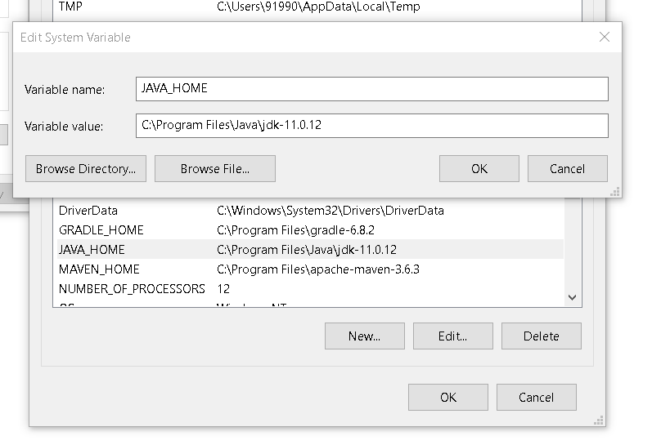

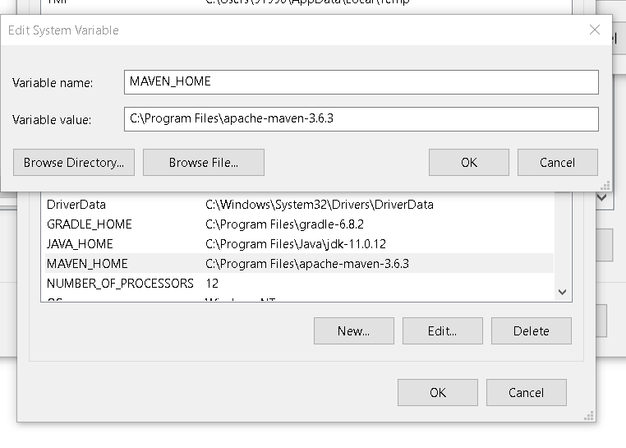

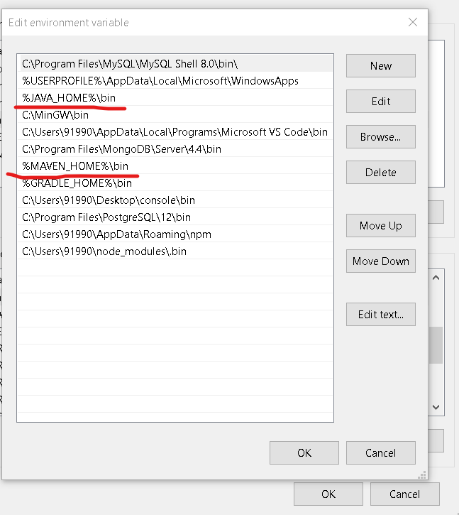

mvn validate : This command is use to pom.xml file syntax.

mvn compile

mvn clean

mvn install

mvn test

MySQL

Student 🡪 Table : Database sid,name,age 🡪 columns

Student -🡪 Java Bean Class : Java Side sid,name,age->property

Main

Student ss = new Student();

ss.setId(100);

ss.setName(“Raj”);

ss.setAge(21);

Student ss1 = new Student(101,”Ramesh”,23);

Java Bean class is known as pure Encapsulation class.

Service class or service layer : This class is responsible to write business logic.

Pure business logic.

Business + database logic

Dao class or Dao layer : Data Access Object :

Pure database logic.

Database -🡪Student

Bean --🡪 Student

Service -🡪 Student business logic

Dao --🡪 Pure jdbc code to insert, delete, update and retrieve

Main class with main method which interact input device.

Dao and Service layer not responsible to interact with input device.

In record in database is equal to one object in Java side.

Do {

1: Add

2: display

3 : delete

4 : update

Switch() {

Case 1:

Case 2:

Case 3:

Case 4:

}

Do you want to continue

}while()